Travel Memory Projects
08 June 2026
04:05 PM

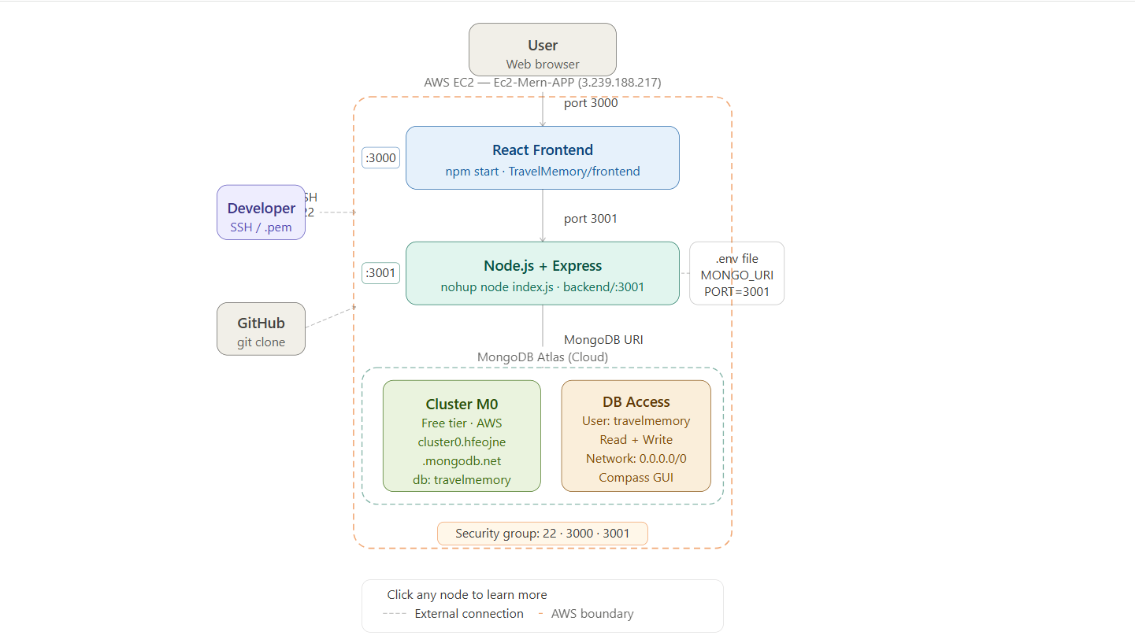

Configuring EC2

Step 1: Update Your EC2 Instance
To ensure your EC2 instance is up-to-date, connect to your EC2 instance via SSH and execute the following commands:

sudo apt update && sudo apt upgrade -y

Step 2: Install Node.js 22 and npm
Node.js can be installed using the NodeSource repository, which provides up-to-date versions of Node.js. Run the following commands:

#Node Source Repository
curl -fsSL https://deb.nodesource.com/setup_22.x | sudo -E bash -
#Install Nodejs
sudo apt install -y nodejs

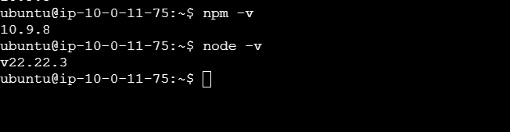

EC2 Details:
Public IP: 3.239.188.217
EC2 Name : Ec2-Mern-APP

Security Group — Inbound Rules
Add the following inbound rules to your EC2 Security Group:
Port | Protocol | Source | Description
22 | TCP | 0.0.0.0/0 | SSH Access
3000 | TCP | 0.0.0.0/0 | Frontend Application
3001 | TCP | 0.0.0.0/0 | Backend Application

Configure the Mongo Database

Step 1: Create a Cluster on MongoDB Atlas
- Sign in to your MongoDB Atlas account. If you don't have an account, create one at MongoDB Atlas.
- After logging in, click on the "Build a Cluster" button.
- Choose "AWS" as the cloud provider and select a region closest to you.
- Select the free tier option (M0).
- Click on "Create Cluster" and wait for it to be provisioned (this may take a few minutes).

Note: Skip Above open because we have already setup

Step 2: Allow Access from Anywhere
Database Access:
- Navigate to "Database Access" in the left sidebar.
- Click on "Add New Database User".
- Enter a username and password (make sure to store these securely — password should be alphanumeric only, no special characters).
- Under "Database User Privileges", select "Read and write to any database".
- Click "Add User".

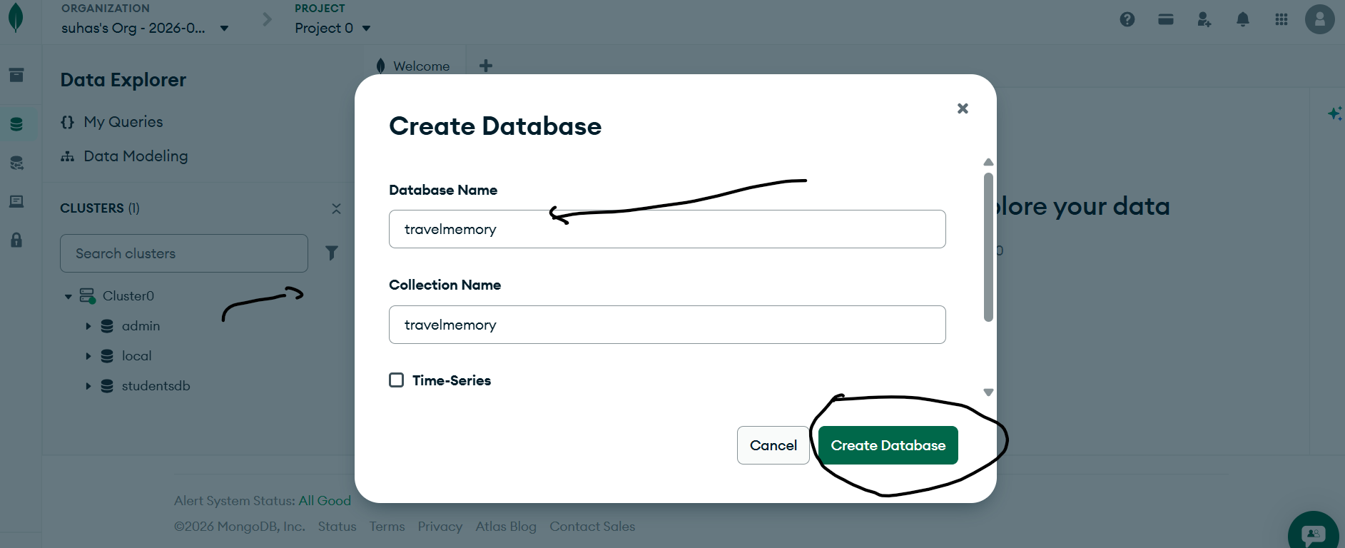

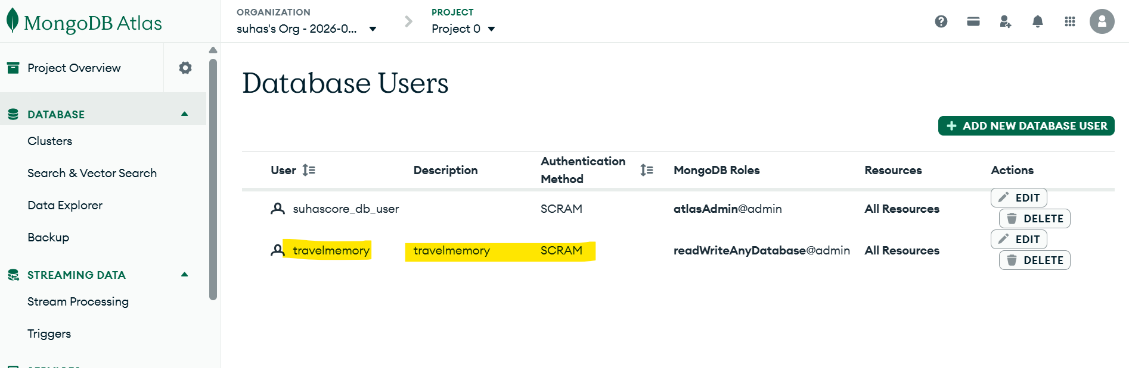

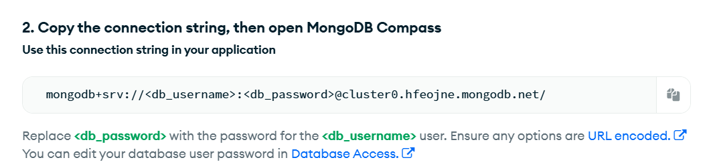

MONGO_URI='mongodb+srv://travelmemory:<********>@cluster0.hfeojne.mongodb.net/travelmemory'

Here's the cleaned-up and well-formatted version:

Step 3: Create a Database Using MongoDB Compass
- Download MongoDB Compass from the official website.
- Follow the installation instructions for your operating system.
- Open MongoDB Compass and, in the connection window, input your connection URI:
mongodb+srv://<username>:<password>@cluster0.mongodb.net/travelmemory?retryWrites=true&w=majority
- Replace <username> and <password> with the credentials you created in Step 2.
- Click "Connect".
- Once connected, click on "Create Database".
- Name the database "travelmemory".
- Create a collection (e.g., "trips").

Step 4: Save Your Cluster Connection URI
Make sure to store your MongoDB connection URI in a secure place, as you will need it for future configurations. The URI allows you to connect to your database from various applications.

Sample Connection URI:

mongodb+srv://travelmemory:<********>@cluster0.hfeojne.mongodb.net/travelmemory?retryWrites=true&w=majority

Deploying a Node.js Application on EC2
In this lesson, you will learn how to deploy the TravelMemory application from GitHub on an EC2 instance. This process includes setting up the Node.js backend, configuring environment variables, and testing the server.

Step 1: Clone the Repository
Clone the GitHub repository to your EC2 instance using the following command:

# git clone https://github.com/UnpredictablePrashant/TravelMemory.git

Step 2: Navigate to the Backend Folder
Once cloned, navigate into the backend folder:

# cd TravelMemory/backend
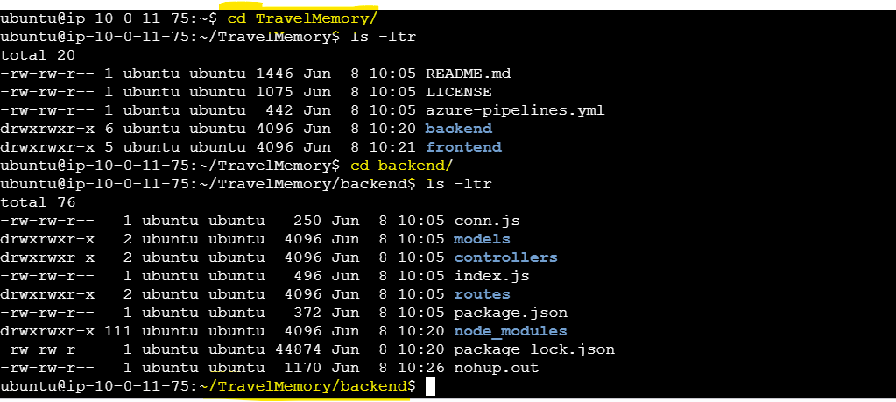

Step 3: Create the .env File

Create a .env file in the backend directory to store your environment variables:

# sudo vi .env

MONGO_URI='mongodb+srv://travelmemory:<password>@cluster0.hfeojne.mongodb.net/travelmemory?retryWrites=true&w=majority'
PORT=3001

Step 4: Install Necessary Packages
Install the required dependencies defined in package.json:

# Sudo npm install

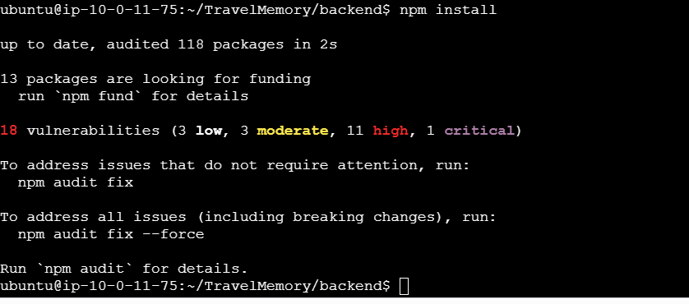

Step 5: Run the Backend Application
Start the backend server using the following command:

#Run in nohup
# nohup node index.js &

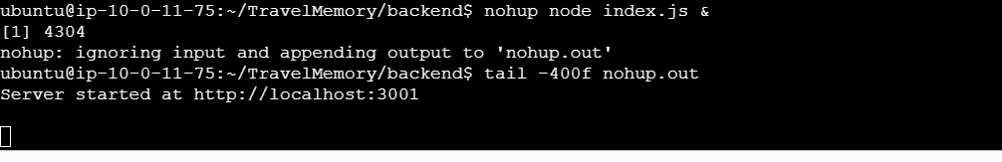

Step 6: Test the API Endpoint
To verify that your backend is running successfully, open your web browser and navigate to:

http://3.239.188.217:3001/hello

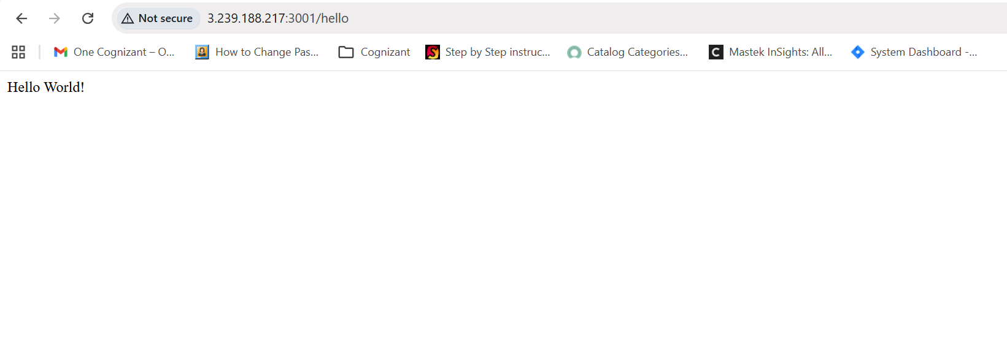

Deploy the React Frontend
Introduction
Secure Shell (SSH) is a protocol that allows you to securely connect to remote servers. Amazon EC2 (Elastic Compute Cloud) is a web service that provides resizable compute capacity in the cloud. In this lesson, we will walk through the process of deploying a React application on an EC2 instance using Ubuntu.

Step 1: SSH to Your EC2 Instance
Connect to your EC2 instance using the following command:
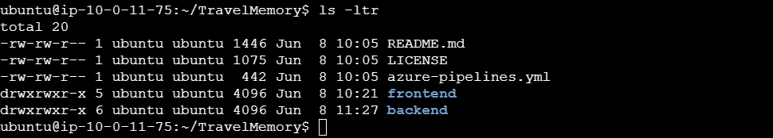

Note: Already connected
Step 2: Navigate to the Frontend Directory
Once connected, navigate to the frontend directory:

# cd TravelMemory/frontend

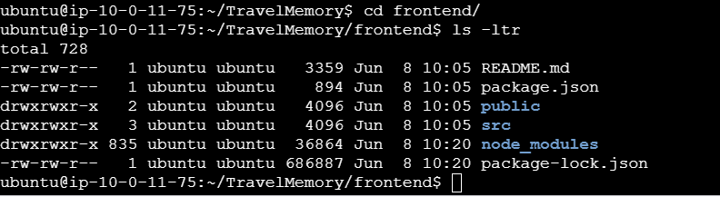

Step 3: Create the .env File
Create a .env file in the frontend directory to store your environment variables:

# echo "REACT_APP_BACKEND_URL=http://EC2_PUBLIC_IP:3001" > .env

Step 4: Install Required Packages
Install all the required dependencies for the React application:
# npm install

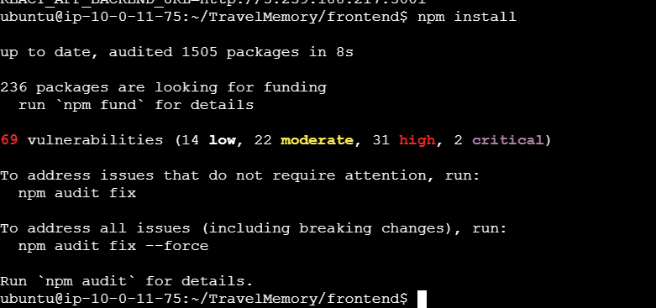

Step 5: Run the Application
Start the React application using the following command:

# npm start

